Guidelines for creating accessible documents
in Microsoft Word

Microsoft Word is a commonly-used application among individuals with a variety of impairments, and does a fairly good job at creating accessible documents. The text within Word documents can be read by assistive technologies such as screen readers and Braille devices. Following these basic steps for implementing these core accessibility principles can help ensure you’re creating a well-structured accessible document.

—

Using Heading/Body Styles
Using good heading structure helps those who are visually impaired understand how the document is organized by way of their screen reader. Screen reader and Braille users can also jump between headings, which makes navigation much more efficient for those using these assistive technologies.

Making text larger and bold does not make it a heading. In order to convert text to a heading in Microsoft Word, you must use the built-in Heading styles like “Heading 1” and “Heading 2”, available under Styles in the Home tab.

Headings should always remain in hierarchical order (H1, H2, H3….H6) Avoid skipping a heading/using them out of order as this can confuse a screen reader and hinder the user's ability to to jump from heading to heading.
If you need additional help with this please visit Microsoft's guidelines on creating Headers.

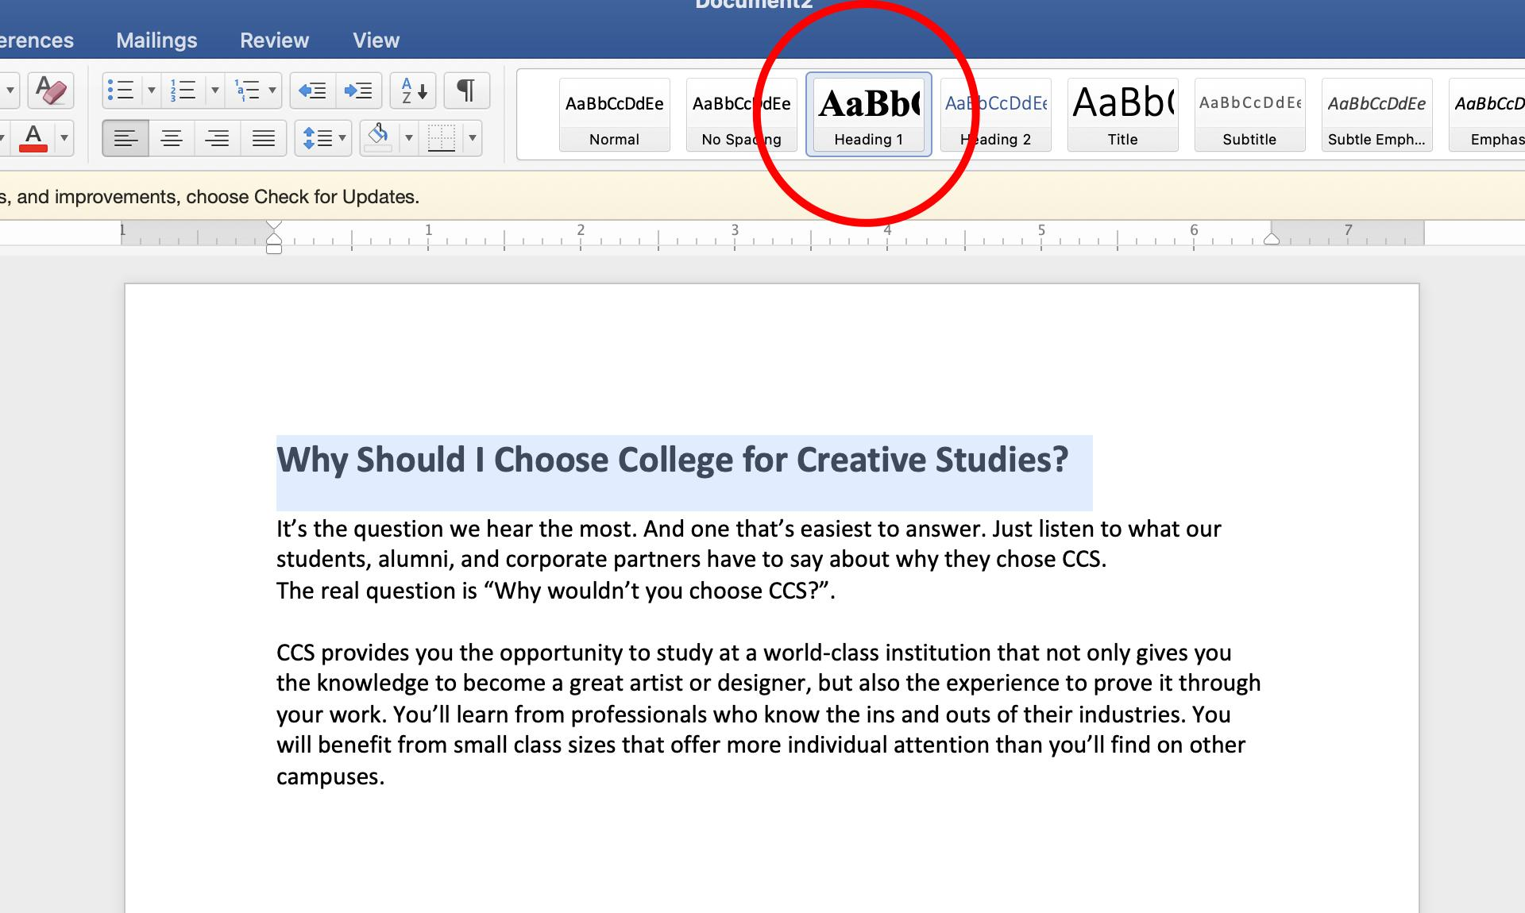
Selecting a Header Style

Using Lists
Lists should be created using Word’s built-in tools for ordered (numbered) and unordered (bulleted) lists. Ordered lists are used for step-by-step lists; when there’s an order to be followed. Unordered lists are for when you simply want to create a list in no specific or inherent order. If you don’t use these styles correctly, a list is not really a list, which makes the content more difficult for screen reader users to fully understand.

An example of an Ordered List (ol) could be directions for a recipe:

- Fill a pot with 1 cup of water
- Add 1 tsp. salt to the water
- Once boiling, add an 1-3 eggs to the boiling water

*These items are done in a specific order, so you would use an Ordered List (ol). Whereas as a grocery list, which has no specific order, would use an Unordered List (ul). An example of that might look like:

- Fish
- Meat
- Eggs

Using Descriptive Links
Descriptive links are links that are worded in a way in which the user can know where they're jumping to without the context of where the link is listed. This may not seem like much to a normal user who sees “read more” after reading a body of content, however, for the visually impaired, this can make a world of difference and helps them know what the link will be taking them to.
Example of a URL link: ​​https://www.collegeforcreativestudies.edu/why-ccs/
Example of a generic link: Learn More
Example of a descriptive link: Why you should choose CCS

Adding Alt-Text for Images
Alt-text, or "alternative text, is the text that a screen reader will read out loud when an image, graphic or table is encountered on a webpage. Alt-text might also be referred to as an "alt tag," "alt attribute" or image description.
Adding this in Microsoft Word is easy. Simply right-click on your image, select ‘Edit Alt Text’ and fill out your image description in the tab that opens.

Note: If an image is simply decorative (ie. no value/information relevant to the page—like a decorative page border), then the alt-text can just be described with the word "null" or "decorative." For more tips guidelines on Alt-Text, please reference the General Accessibility Guidelines Document

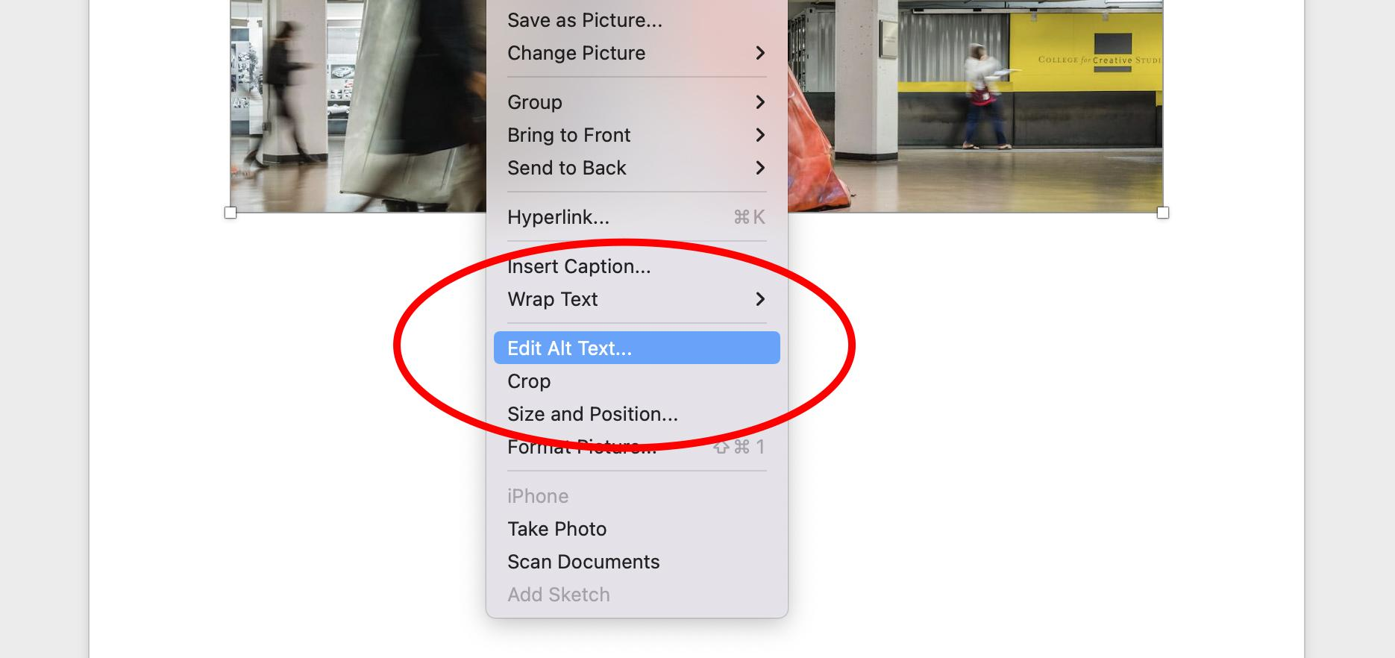
Adding alt-text to an image

Identifying your Document’s Language
In Microsoft Word, select Tools > Language from the application menu to define the default language. To define a different language for part of the document, select each foreign language individually, then select Tools > Language to define the language for each.

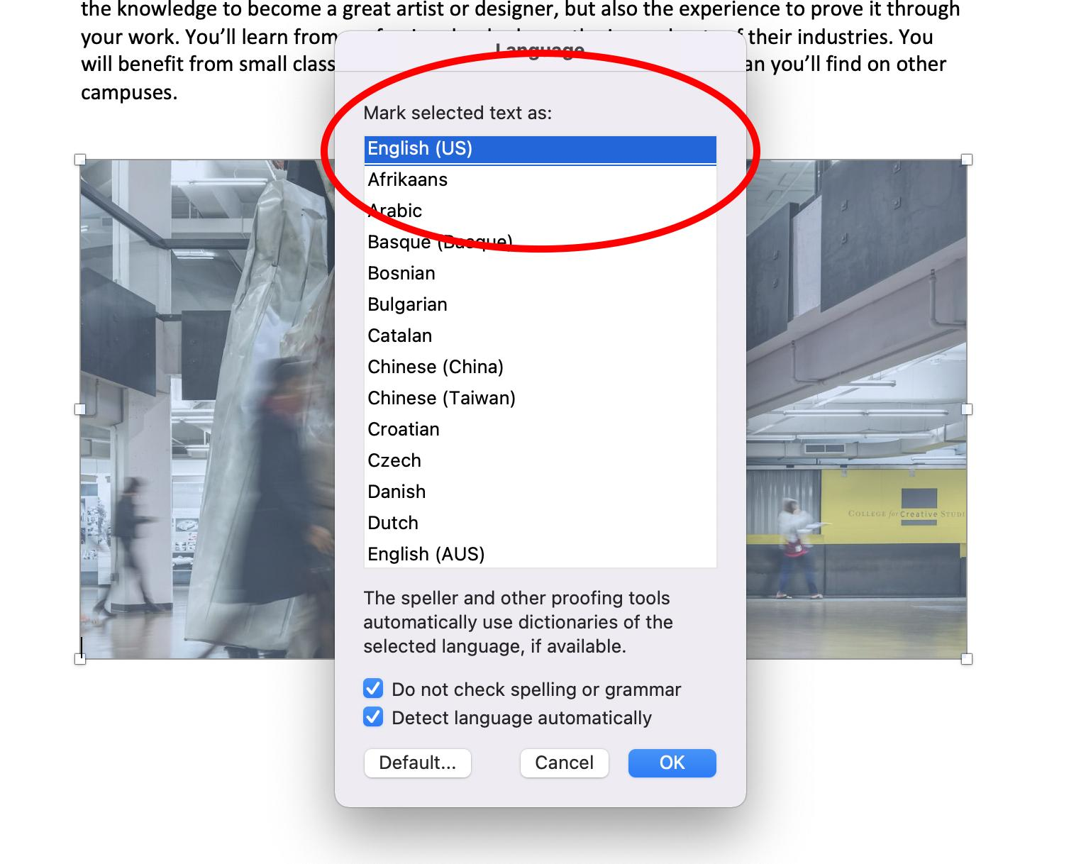
Setting your document’s language

Using Tables
Tables are a great way to organize data using rows and columns. While they’re easy for screen readers to read, they shouldn’t be used for convenience or as a design element; they should always have a purpose.

There are a few important steps in making sure your table is being built correctly.
Include a Header Row
This row is used to state what kind of information is contained in each column. This provides context for the data and assists screen readers in navigating the table.
Like Headings, header rows require a little extra formatting to be meaningful to screen readers. To make a header row:
- Choose Insert > Table to insert a table.
- Choose the number of boxes you want across to create columns, and then choose the number of boxes you want down to create rows for your table.
- On the Design tab, choose the Table Styles Options group, and then choose Header row.

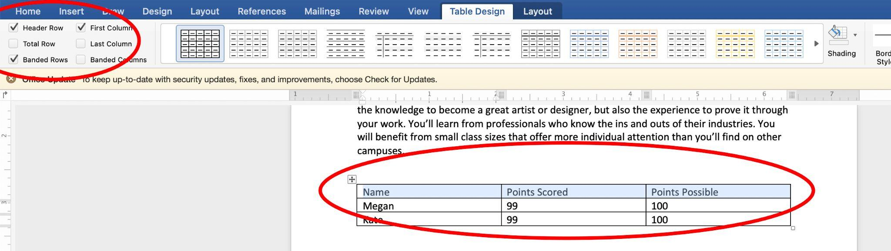
Setting a Header row

Use a simple structure
Avoid using screenshots of tables, nesting tables within tables, and merging or splitting cells. All of these will make it very difficult, if not impossible, for screen readers to read the information in a logical way that makes sense to the user. An example of a poorly constructed table might look something like this:
Name | Points Scored | Points Possible
Megan | 99 | 100
Kate | 99 | 100

*This is a properly formatted, simple structured table.

Color Contrast
Avoid layering text or colors on top of each other whenever possible. Layering colors can cause visual issues for those who are visually impaired; for example, individuals who are colorblind.

Stick to the standard black (#000000), or an accessible grey tint such as #242424, or #444444 for text. If you’re stuck using a color or are choosing to layer colors, use a color contrast checking tool to make sure it’s accessible. A great resource for this is WebAim’s Color Contrast Checker

Use the Accessibility Checker
Microsoft products have a built-in accessibility checker which can help the document author test the overall accessibility of the document. The checker provides Inspection Results, feedback about the importance of each item, as well as tips on how to repair issues.

You do this by going to the ‘Review’ tab in your document and selecting “Check Accessibility”

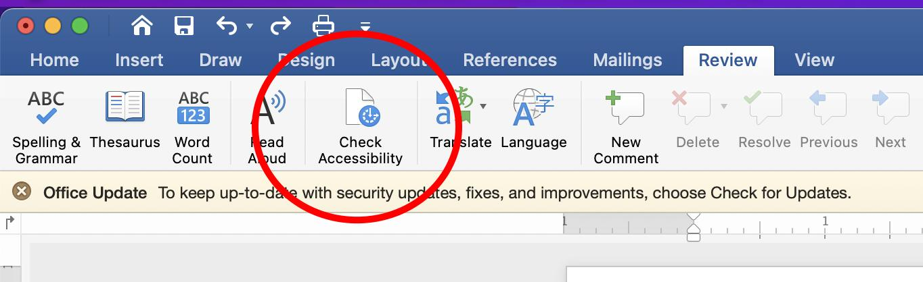
Using Microsoft Word’s Accessibility Checker

Exporting your Document as a PDF
When you're finished creating your document, and have run your accessibility check and made sure everything looks ok and is accessible, you’re ready to export it as a PDF. Simply go to File > Save As, and select PDF from the dropdown menu.
Make sure the radio button for “Best for electronic distribution and accessibility” is selected as this will ensure your document’s accessibility will remain intact.

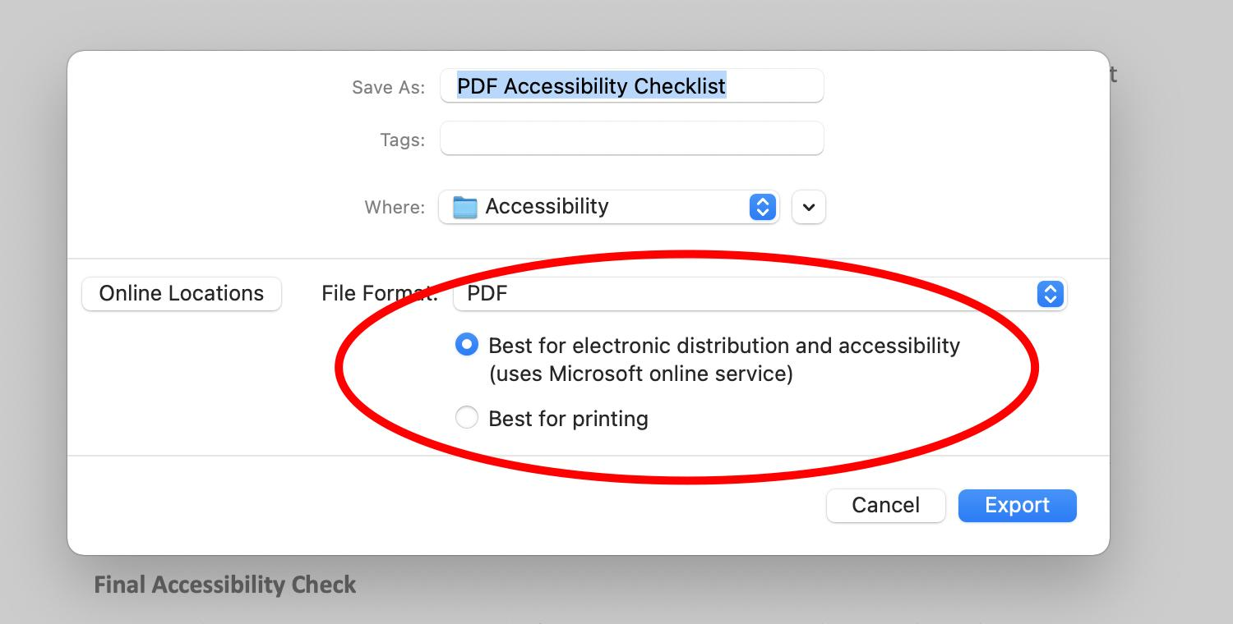
Exporting your accessible Word Document as a PDF

Adobe Acrobat
Once you’ve exported your accessible PDF, you can check it using Adobe Acrobat. To use this tool to run an additional accessibility check, open your PDF in Adobe Acrobat. You will see a menu on the right side of your screen, and an icon for Accessibility. If you don’t see that icon there, navigate to the top left of the acrobat window and selected the ‘Tools’ tab—scroll down until you see the Accessibility tool, and click ‘Add’

Once you’ve done that, click the accessibility tool and run the check. Once the report is complete, a small report will pop up the left of your document. Make sure there are no errors, or follow the links and descriptions Acrobat will provide to remedy the issues.

Pave
This is an online tool that goes a little more in-depth, but also allows you to make revisions and add things such as alt-text and link descriptions right into the document you’re checking before allowing you to export your document. Once you upload your document, it will give you a page by page breakdown of all of the errors it finds throughout the document and will allow you to make the necessary revisions to correct them. Because it’s a more in depth tool, it provides you opportunities to correct a lot of smaller errors that aren’t as common or noticed, but is good practice for those getting into accessibility and wanting to know what to look out for when creating accessible documents for the web.

Use PAVE’s PDF Accessibility Checker

